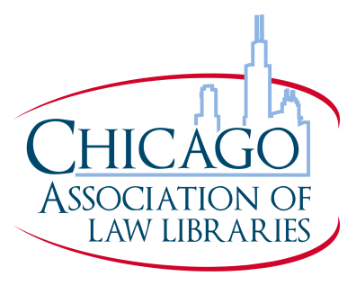

Chicago Association of Law Libraries Awards Nominations Form

Please designate which award you are nominating an individual or group for:

_____ Agnes and Harvey Reid Award for Outstanding Contribution to Law Librarianship

_____ Award for Outstanding Lifetime Achievement in Law Librarianship

_____ Award for Outstanding In-House Publication

Nominee(s):

Please attach a statement detailing the contributions of your nominee(s), including relevant service, activities, and positions held in CALL, or bibliographic information for any work product. Please be as complete in your nomination documentation as possible.

CALL Awards Selection Criteria can be viewed on the website at: http://new.chicagolawlib.org/grants-and-awards/call-awards-selection-criteria/

Mail or email this form with all necessary attachments by March 29, 2019 to:

Clare Willis
Pritzker Legal Research Center
375 East Chicago Avenue
Chicago, Illinois 60611-3069
Clare.willis@law.northwestern.edu

The CALL Grants and Chapter Awards Committee will not consider incomplete or late applications for review.

