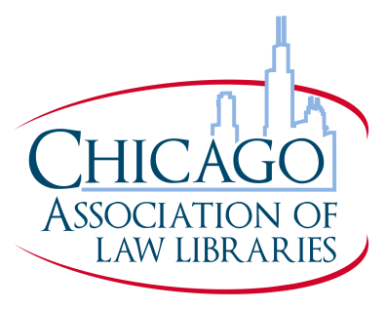
CALL GRANTS APPLICATION 2020-2021
The CALL Grants and Chapter Awards Committee offers grants to the membership in various amounts for attendance at continuing education programs and the AALL Annual Meeting and Conference.
Continuing Education Grant Applications must be received by the Committee Chair no later than three weeks before the start date of the program or workshop.
Applications for the 2021 AALL Annual Meeting and Conference are due March 31, 2021.
Incomplete applications and those received after the deadlines indicated above will not be considered.
Grant awards may be used only for registration, transportation and lodging.
Please check one: [ ] Continuing Education [ ] AALL Annual Meeting and Conference

NAME:________________________________________________________________
ORGANIZATION:________________________________________________________
JOB TITLE:_____________________________________________________________
ADDRESS:_____________________________________________________________
PHONE: _______________________________________________________________
E-MAIL ADDRESS: ______________________________________________________
Length of Membership in CALL: ___________________________
List your activities in CALL, AALL or other professional organizations (list any office held, committee participation or other activities, including dates of your participation). Please limit this to the last five years. If you need additional space, please attach additional sheets.
Have you ever received a CALL grant? Yes No
If yes, please provide the details of that grant including when it was received, the amount awarded, and the education program that you attended
Amount of grant money requested: $_____________________________
For what purpose do you wish to use this grant? (provide program registration information and a list of itemized expenses where the requested money will be spent)
What benefit will you receive by attending this education program?
[ ] Letter of Recommendation attached
One letter of recommendation is encouraged, but not required. This letter must accompany your application and be from a person who is familiar with your responsibilities and can provide information about your potential to contribute to the field of librarianship and to CALL.

Answer the following questions if grant will be used for AALL Annual Meeting & Conference:
For an AALL Annual Meeting grant, please list specific educational programs that will aid your professional development.
Are you a member of AALL? Yes No If yes, how long? ________________________
Have you ever attended an AALL Annual Meeting? Yes No
If yes, how many have you attended and when was your most recent attendance?
I AGREE THAT, IF FOR ANY REASON, I AM UNABLE TO ATTEND THE PROGRAM FOR WHICH THE GRANT IS AWARDED, I WILL IMMEDIATELY NOTIFY THE CALL GRANTS AND CHAPTER AWARDS CHAIR AND RETURN THE GRANT MONIES TO CALL. IF THE CALL GRANT HAS ALREADY BEEN PAID AND A REFUND CANNOT BE OBTAINED, I WILL REPAY THE AMOUNT OF THE AWARD.
I AGREE TO PROVIDE RECEIPTS (PHOTOCOPIES ACCEPTABLE) DOCUMENTING MY ATTENDANCE AT THE PROGRAM WITHIN 30 DAYS OF MY RETURN TO THE CHAIR.
IF I DO NOT USE THE FULL AMOUNT OF THE GRANT, I WILL RETURN THE UNUSED PORTION TO THE CALL TREASURER IMMEDIATELY.
I FURTHER AGREE TO SUBMIT AN ARTICLE ON THE PROGRAM/MEETING SUPPORTED BY THE GRANT FOR THE NEXT ISSUE OF THE CALL BULLETIN.
Applicant’s Signature:___________________________________ Date:__________________________
Send applications to:
Jessie LeMar
CALL Grants and Chapter Awards Committee Chair, 2020-2021
Skadden, Arps, Slate, Meagher & Flom LLP
155 N Wacker Dr STE 2700
Chicago, IL 60606-1720
Jessica.lemar@skadden.com

